Project Scenario 1: Small Business Network

Requirements
The company has:
- Management Department (VLAN 10)
- Sales Department (VLAN 20)
- IT Department (VLAN 30)
Each department should:
- Be separated using VLANs
- Communicate with other VLANs through Inter-VLAN Routing
- Receive IP addresses automatically via DHCP
- Use a DNS server for name resolution

1. Objective
To design and implement a small business network using VLANs, trunking, inter-VLAN routing, DHCP and DNS services within Cisco Packet Tracer.

2. Network Topology
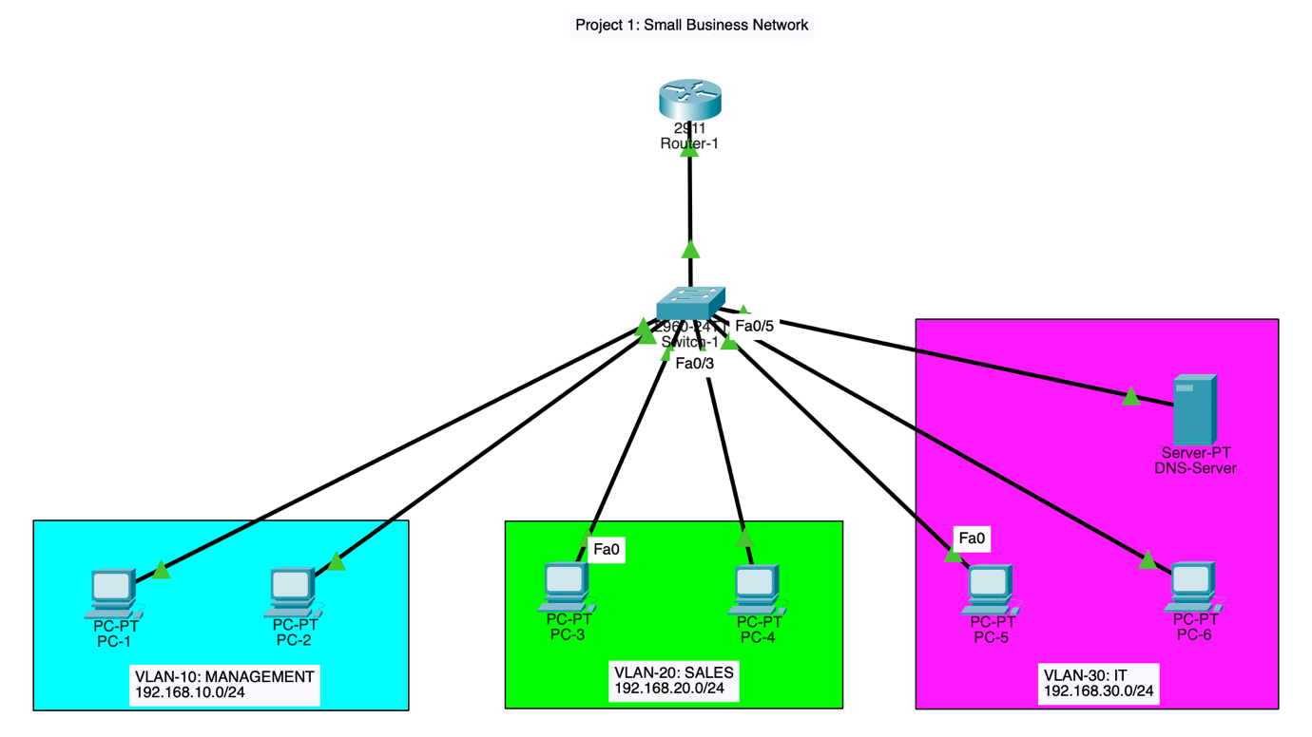

3. IP Addressing Scheme
VLAN | Department | Network | Gateway
10 | Management | 192.168.10.0/24 | 192.168.10.1
20 | Sales | 192.168.20.0/24 | 192.168.20.1
30 | IT | 192.168.30.0/24 | 192.168.30.1

4. Switch Configuration
Create VLANS on Switch-1:
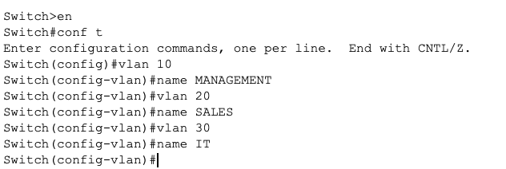
VLAN Brief:
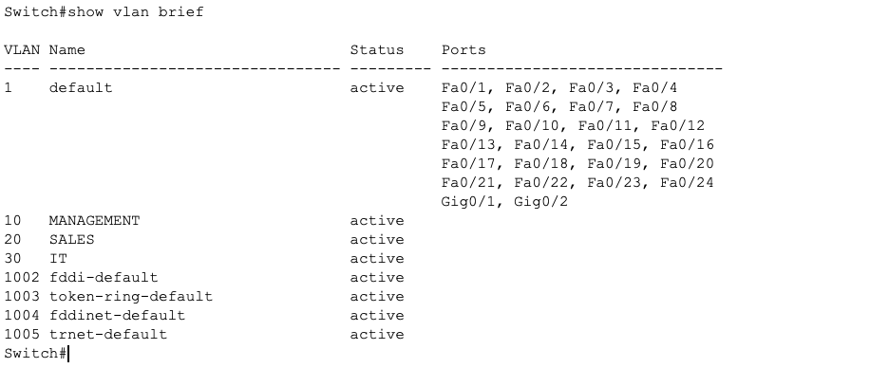
Assigning Ports to each VLAN:
Device | VLAN | Port
PC-1 | 10 | Fa0/1
PC-2 | 10 | Fa0/2
PC-3 | 20 | Fa0/3
PC-4 | 20 | Fa0/4
PC-5 | 30 | Fa0/5
PC-6 | 30 | Fa0/6
DNS-Server | 30 | Fa0/7
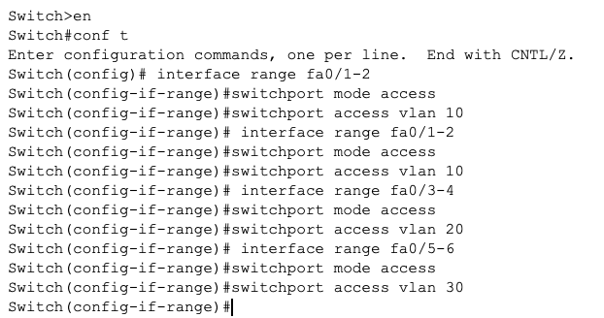
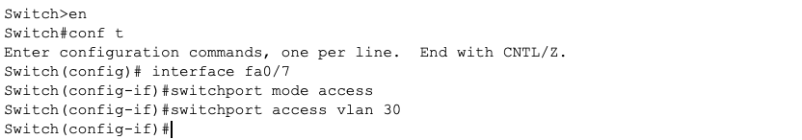

Configure Trunking: The switch-to-router connection must carry all VLANs.
Since the router connected to interface g0/1:
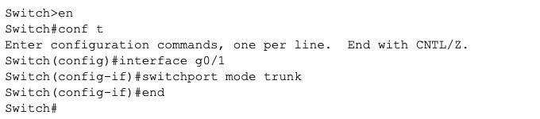
Running-Config Verification:
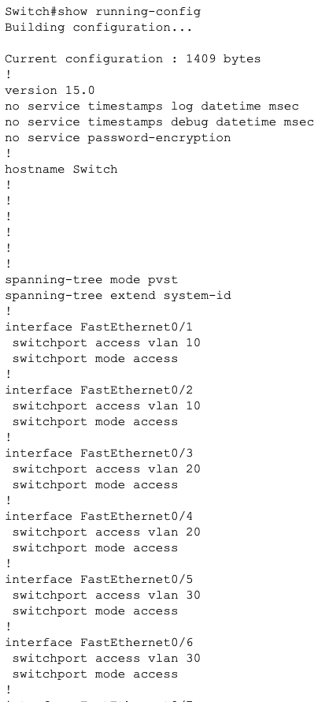
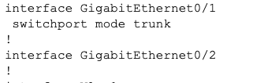

5. Router Configuration
Configure Inter-VLAN Routing: This is Router-on-a-Stick.
Router interface:

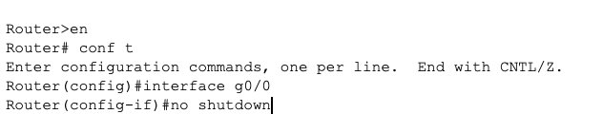
Create sub interfaces: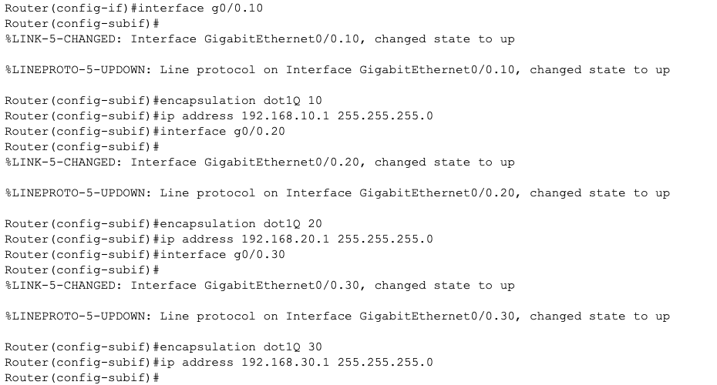
Verify with interface brief:
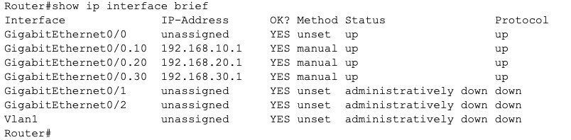

6. DHCP Configuration
The Router will provide DHCP. Exclude gateway addresses:
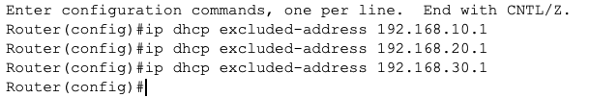
DHCP VLAN Pools:
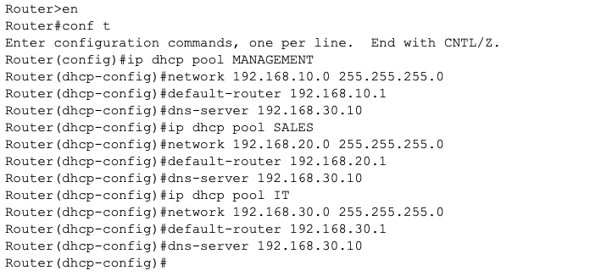

7. DNS Configuration
Desktop IP Configuration:
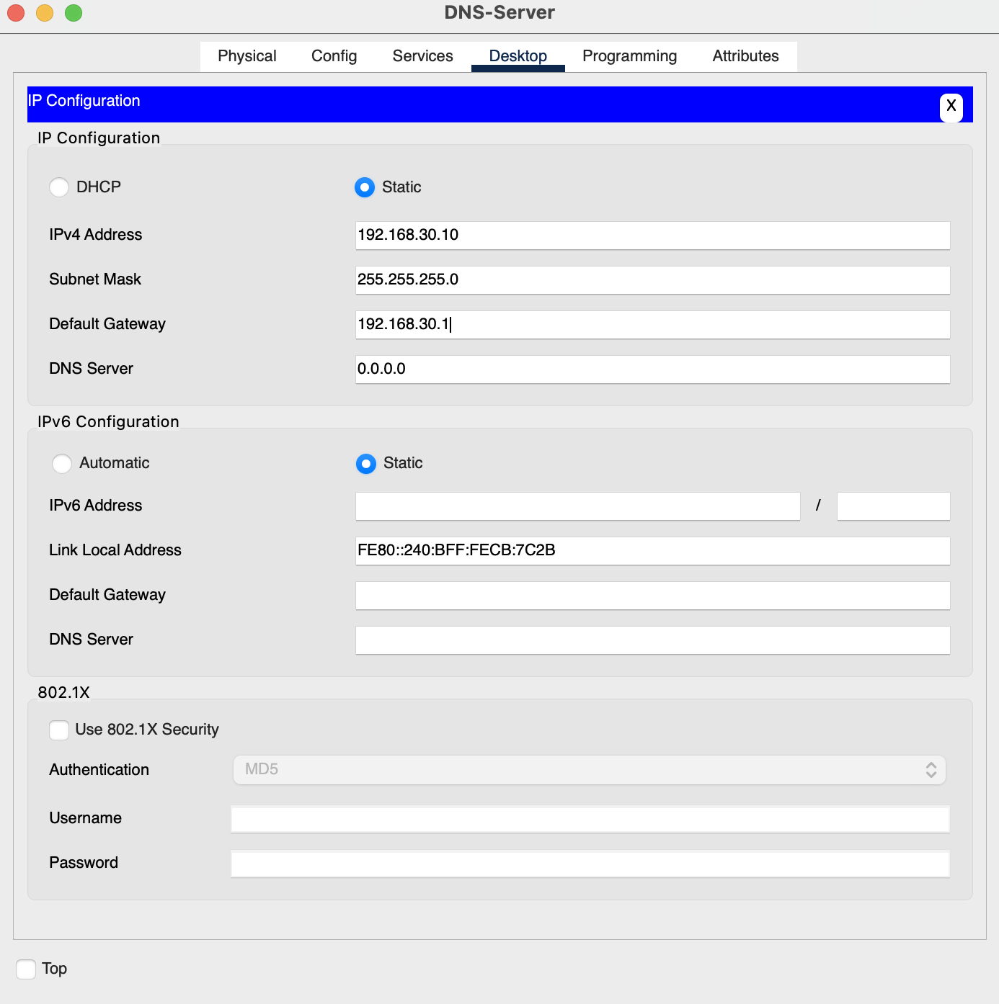
Service Records Config:
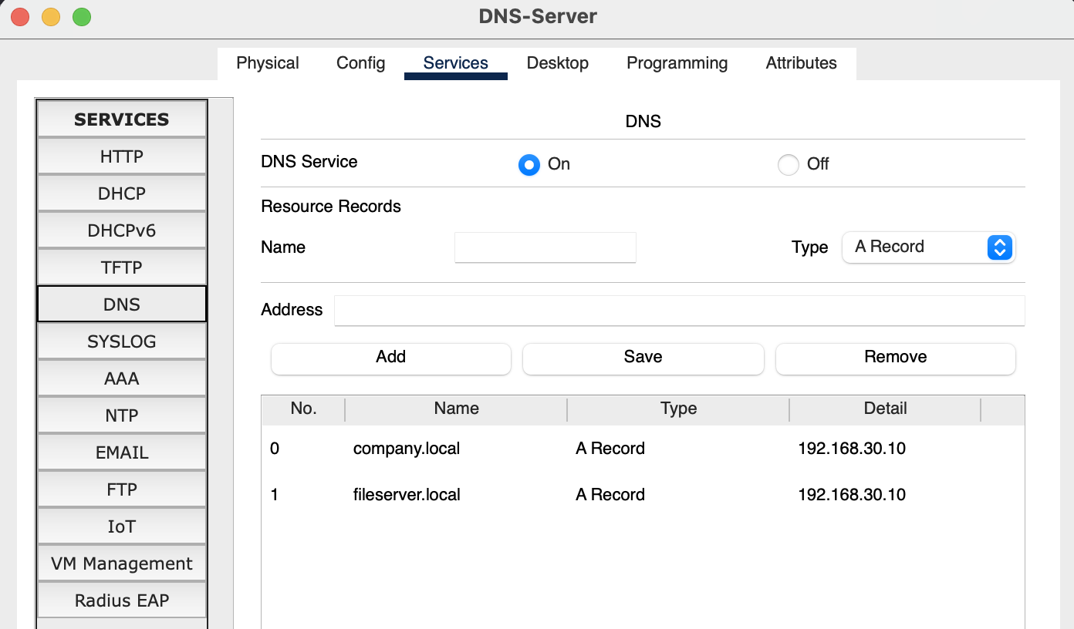

8. PC Configurations
All PC’s are using DHCP for IP Configurations
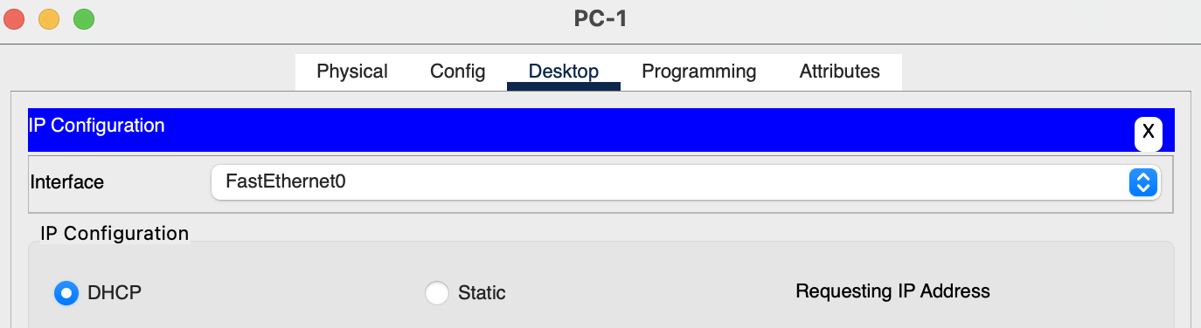
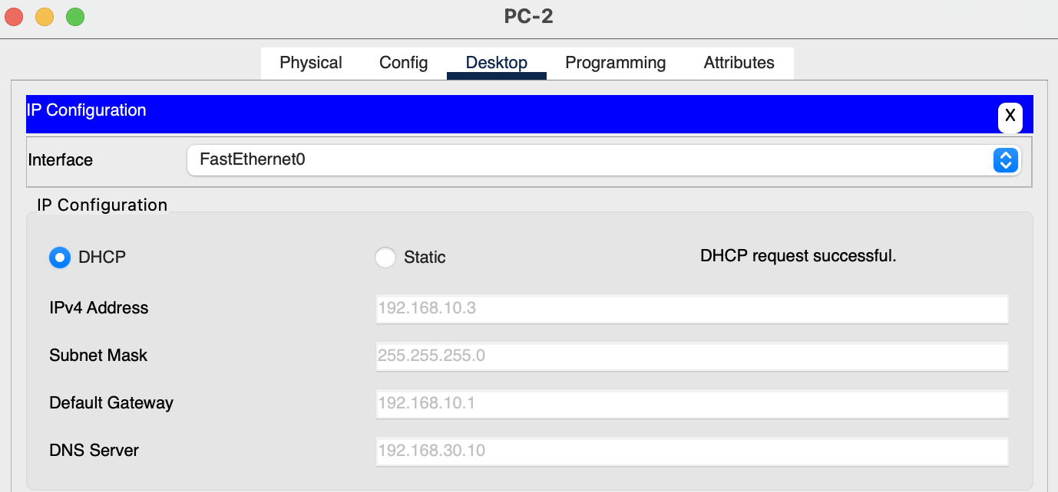

9. Testing Results
Include screenshots of:
Test 1 – DHCP:
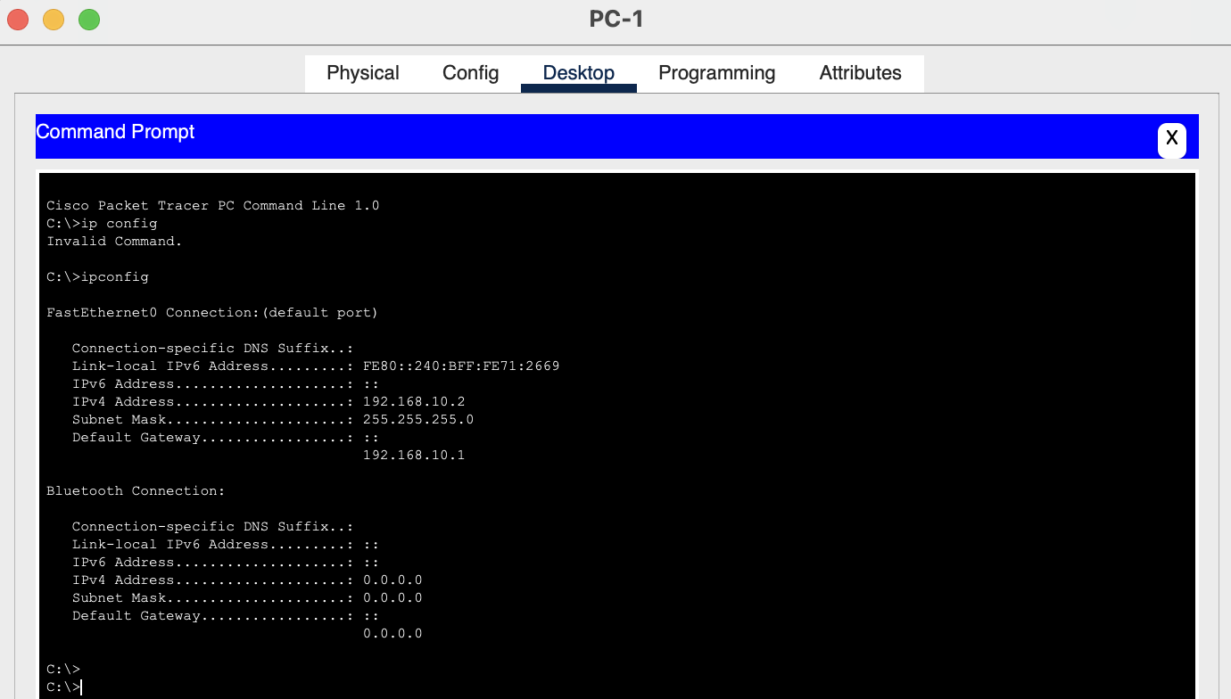
Result: Confirms correct subnet and IP Address.

Test 2 – Gateway:
ping 192.168.10.1
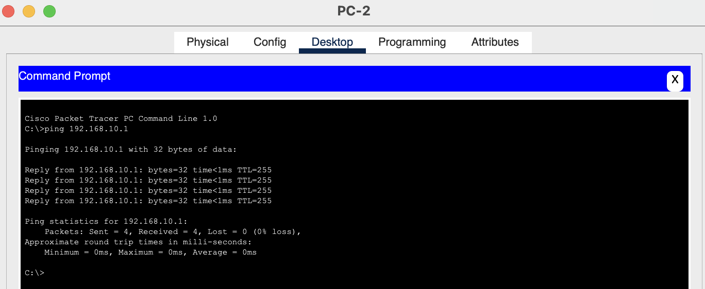
Result: All packets sent to default gateway with no issues.

Test 3 – Inter-VLAN Routing:
From VLAN 20 (SALES) PC:
ping 192.168.10.1
ping 192.168.30.1
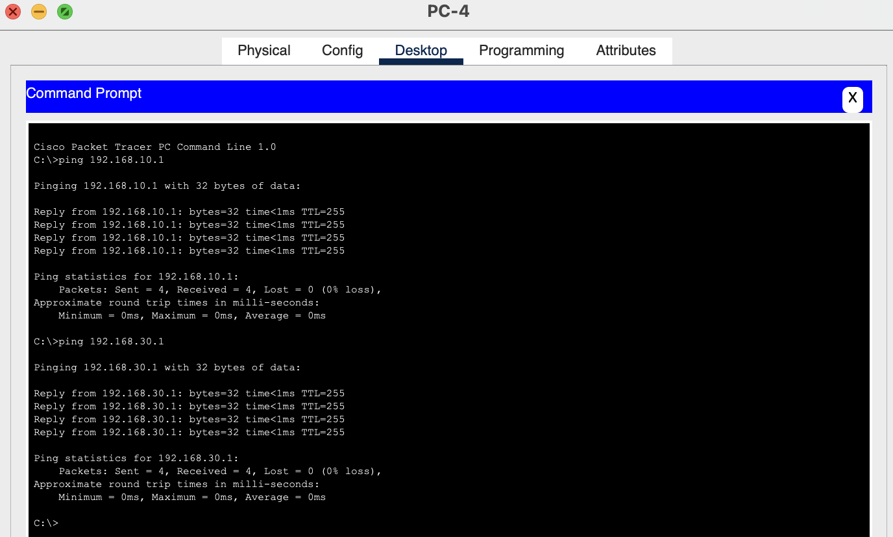
Result: PCs in each VLAN are able to ping the other default gateways

Test 4 – End-to-End Connectivity
PC in VLAN 30:
ping <IP of PC in VLAN 20>
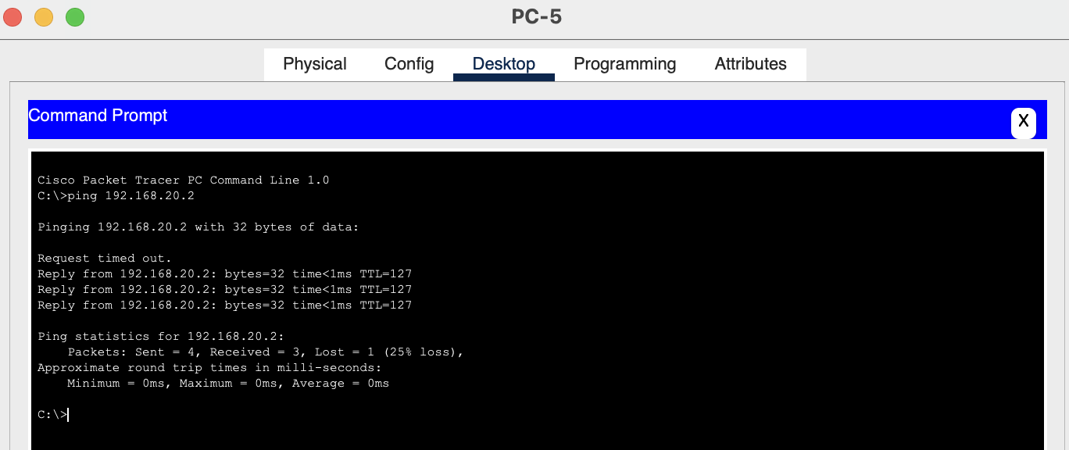
Result: First request timed out but all other packets sent by PC-5 were received by PC-3.

Test 5 – DNS
ping company.local
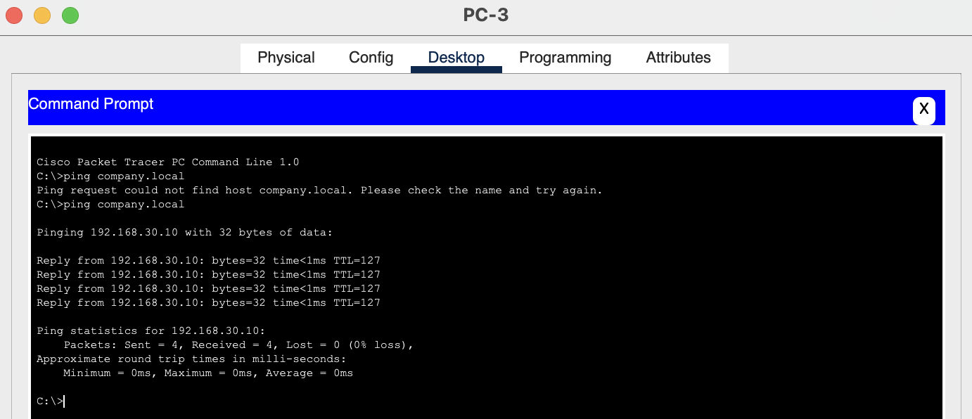
ping fileserver.local
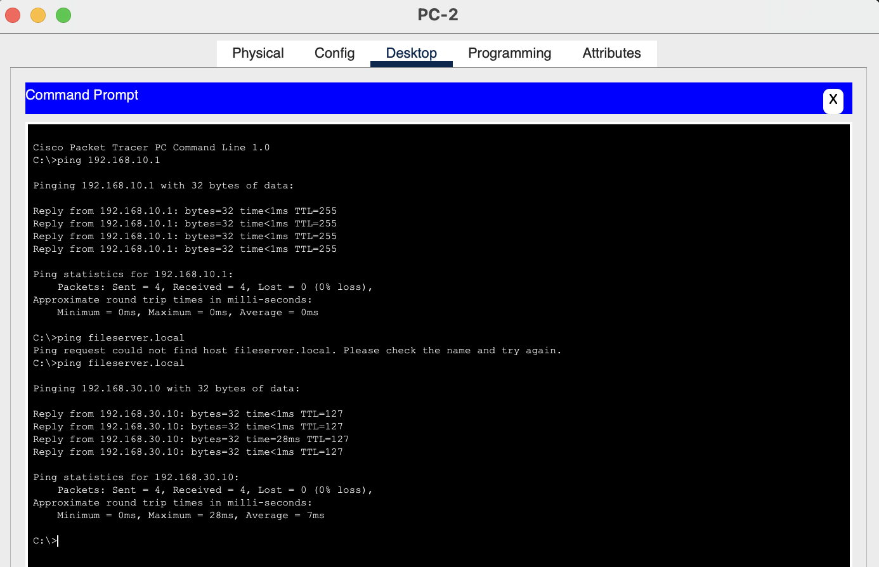
ping 192.168.30.10
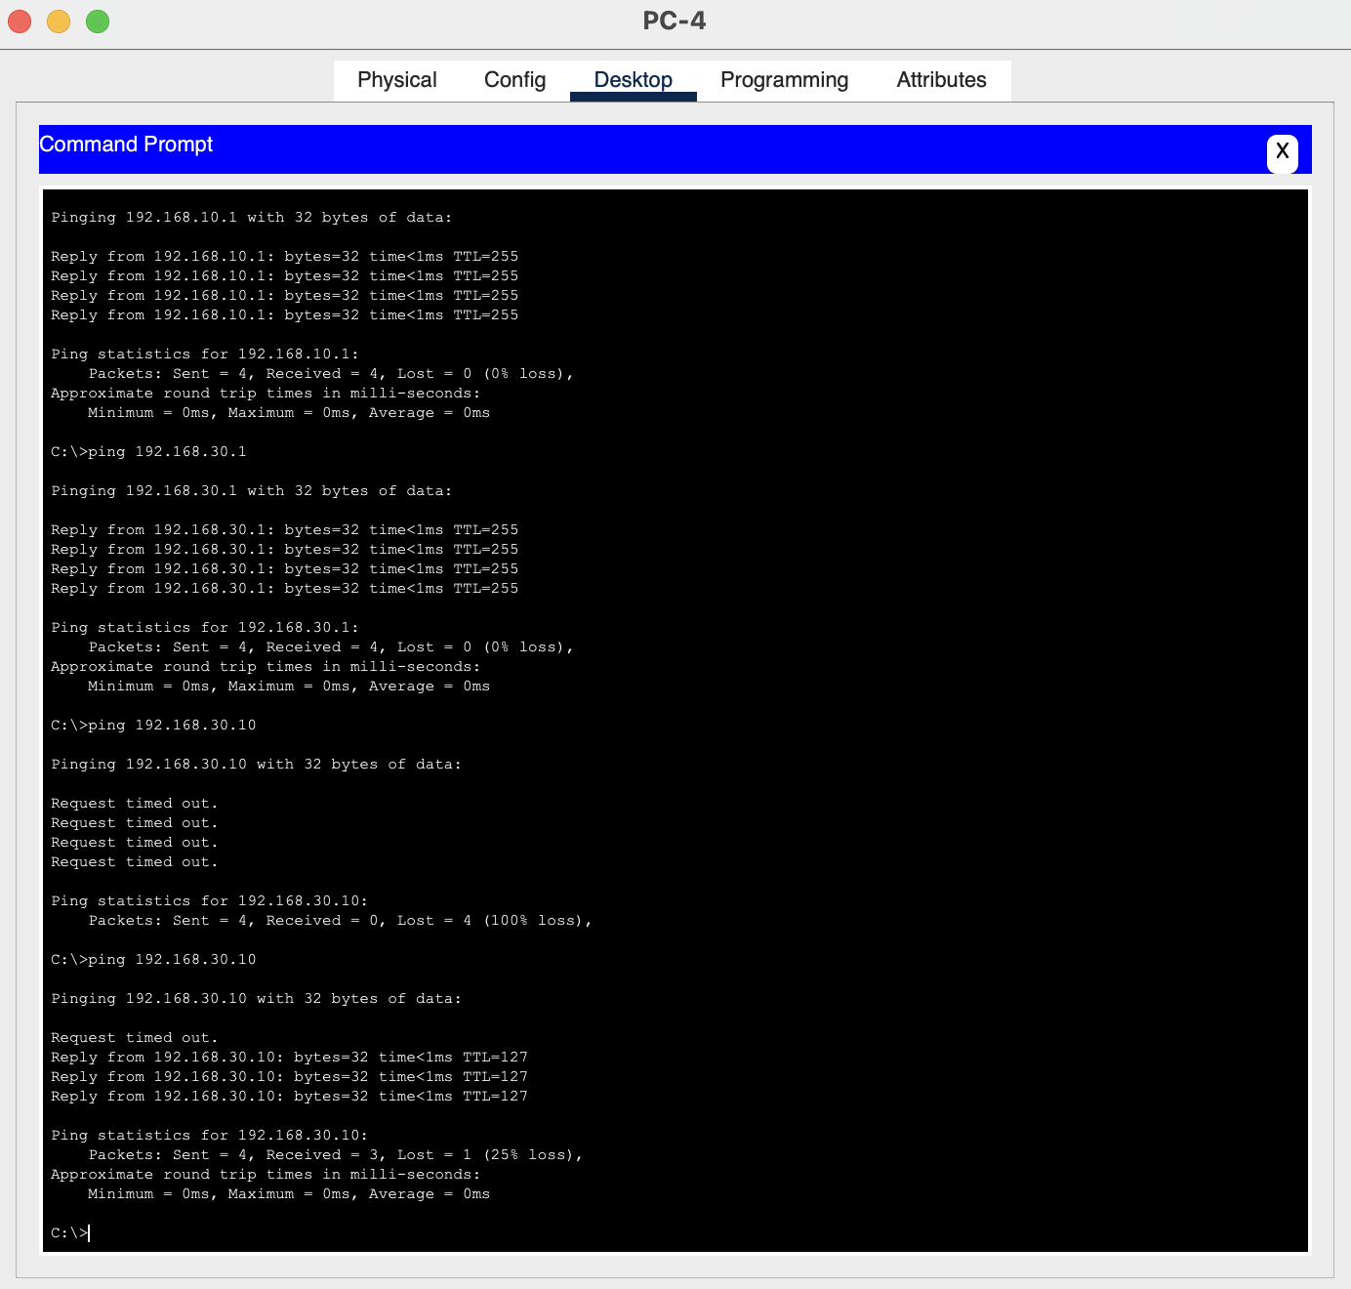
Result: The DNS resolves to 192.168.30.10 and multiple PC’s are able to ping the DNS Server

10. Conclusion
The network was successfully configured using VLAN segmentation, trunking, router-on-a-stick inter-VLAN routing, DHCP for dynamic host addressing, and DNS services for hostname resolution. Connectivity tests confirmed successful communication between VLANs and proper DNS functionality.

